How principal components are implemented:

- Historical data is transformed into returns (modeltype=2) or first differences(=1). Let X= returns or changes.
- The algorithm accepts a parameter that defines which row to use for the seed.
- Principal components are created based on the variance-covariance matrix of the returns data. (standard method).
- Principal components as plotted represent 1 std dev move for each component.
- See Greene for additional detail.

Simulations:
- Based on a user selection random number Z’s are generated:
  - From the normal distribution or (e.g. PCScores = Z*PCstdev),
  - From the students-t distribution with the used-defined degrees of freedom (fatter tails than the normal but symmetric).
  - Historical distribution. Assuming the components are independent, and then the empirical cdf is generated and interpolated from the data transformed in the principal components.
  - Random numbers are antithetic (the algorithm ensures that for each # at the x %ile there is a # at the 100-x %ile. This is done by be generating random numbers u from the uniform distribution and for each u using 1-u. Note that this ensures a symmetric distribution for the normal and students-t, but the skew present in the historical distribution will be maintained.
- XSims = PCScores * PC’ * Xstdev is the simulated returns. That is, map PCScores to X space. Note that we need the last multiplication be Xstdev because we derived PC’s based on the covariance matrix.
- Simulated returns can be sued to generate simulations using any seed X0 where X0*exp(XSims *sqrt(dT) - 0.5*dT * XVarance ) for returns (lognormal) or X0 + XSim*dT for first differences.
- See Clewlow or James and Weber for more theoretical detail.

See the VBA code in module 2 of the “Coal API2” spreadsheet for an example of how to use the simulation.
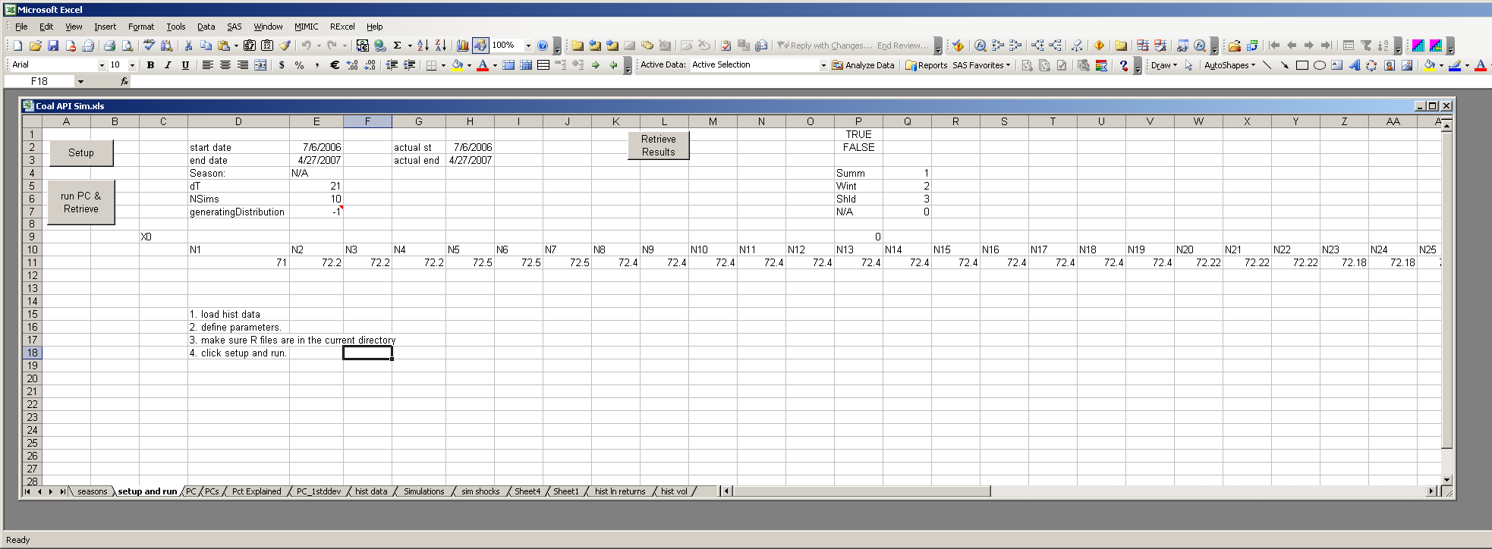

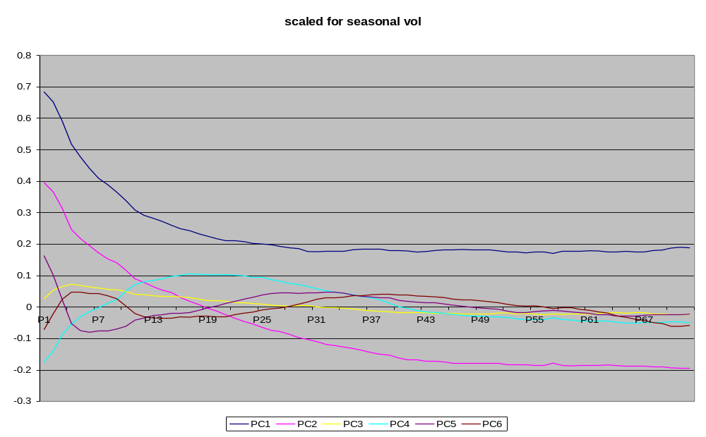
NYMEX NG PC

Coal – API2
